FIA Cross Car Technical Regulations 2025

With Estonian National specificities

**ART.1 DEFINITION**

**1.1** Cross Car (XC) and Cross Car Junior (XC Jr.):

Rear engine 4-wheeled single-seater land vehicles, solely designed for races on off-road circuits, with a multitubular space frame chassis which must have a safety cage as an integral part of the chassis, as defined in Article 12. The propelling device and steering are controlled by a driver on board the vehicle.

The vehicles must be 2-wheel rear drive.

Unless expressly stated in these regulations, all articles apply to the Cross Car (XC) and Cross Car Junior (XC Jr.) categories.

**1.1.1 Dangerous construction**

A car, the construction of which is deemed dangerous, may be disqualified by the Stewards of the competition.

**1.2 Technical passport**

For FIA championships, the FIA technical passport must be presented at scrutineering for the competition.

In addition, the markings linked to the technical passport must not be removed under any circumstances.

**ART.2 MODIFICATIONS AND ADJUNCTIONS ALLOWED OR OBLIGATORY**

**2.1** All modifications which are not explicitly allowed by the present regulations are forbidden.

An authorised modification may not entail a non-authorised modification.

**2.1.1 Optional devices**

If a device is optional, it must be fitted in a way that complies with regulations.

**2.2 Material**

Unless explicitly authorised by the present regulations, the use of the following material is prohibited unless they correspond exactly to the material of the original part or of a powertrain homologated part:

• Titanium alloy

• Magnesium alloy (< 3 mm thick)

• Ceramics

• Composite or fibre-reinforced material

Titanium alloy is permitted for quick release connectors of the braking circuit.

The use of composite material (cf. Article 251-2.1.11.c) is authorised for the following elements:

• Homologated parts of the powertrain

• External air filter mounting parts (Art. 4.12)

• Air ducts for cooling (cockpit and boot / radiators / intercooler / engine ancillaries / brakes)

• Seats

• Supports and fixings fitted inside the cockpit (except seat brackets)

• Driver footrest

• Console / support for switches

• Bodywork protections (side, floor, wheel arch)

• Bodywork

• Underbody protections

• Supports and fixings fitted inside the engine compartment (except engine supports / transmission supports)

• Fuel tank internals

• Electric connecting box

• Brake pads

**2.3 Screws, nuts and bolts.**

Unless explicitly authorised by the present regulations or unless it corresponds exactly to the material of the original part, all threaded fasteners must be manufactured from iron-based alloy.

Powertrain homologated parts are exempted from this requirement.

**2.3.1 Damaged threads**

Damaged threads can be repaired by screwing on a new thread with the same interior diameter ("helicoil" type).

**2.4 Fuel – combustive**

The cars must use fuels - combustives complying with Article 252-9.1. of Appendix J.

**2.4.1 Oxidant**

Only air may be mixed with the fuel as an oxidant.

**2.4.2 Estonian National (valid until 31.12.2026)**

It is permitted to use commercially available fuel provided by retail fuel stations. The maximum octane rating of fuel is 98 or Aspen 98+. Any fuel additives are prohibited. Methanol and E 85 are prohibited.

**2.5 Driving aids**

Unless explicitly authorised by the present regulations, any driving aid system is prohibited (ABS / ASR / Traction Control / ESP…).

Any such system must be rendered inoperative.

**2.6 Energy recovery**

Any energy- recovery system other than that provided by the engine is prohibited.

Any exhaust energy recovery system is prohibited.

**2.7 Telemetry / Voice communications**

Any form of wireless data transmission between the vehicle and any person and/or equipment is prohibited while the car is on the track.

This definition does not include:

• Voice radio communications between the driver and his/her team

• Transponder from the official timekeeping, and

• Automatic timing recording.

None of the previously mentioned transmission data may in any way be connected with any other system of the car (except for an independent cable to the battery only).

On-board data recorders are permitted.

These systems, with or without a memory, may permit only the reading of:

• The speed of one wheel

• An X/Y/Z accelerometer according to the following coordinates:

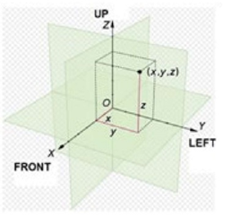

• GPS data

• Lap times

• CAN data transmitted by the homologated ECU and software.

The transmission of data by radio and/or telemetry is prohibited. On-board TV cameras are not included in the above definitions. However, the equipment and supports must first be approved at scrutineering.

**2.8 GPS Units**

GPS Units are allowed as long as:

• there is no wire or wireless connection with any of the electronic systems of the car.

This definition includes in particular the dashboard, meters, the engine management unit, etc.

**2.9 On-Board competitors’ camera**

The fixing device must withstand a deceleration of 25g without detaching, must be inside the cockpit and must be approved by the scrutineers.

The camera must not hinder the driver’s visibility, exit or extrication in case of emergency.

**ART.3 PRESCRIPTIONS FOR CROSS CARS**

**3.1** These cars must comply with the following Articles of Appendix J:

**ARTICLE 251 (Classification and definitions)**

2.1.9 Mechanical components

2.2 Dimensions

2.3.1 Cylinder capacity

2.3.8 Engine compartment

2.5.1 Chassis

2.5.2 Bodywork

2.5.3 Seat

2.5.5 Cockpit

2.7 Fuel tank

**ARTICLE 253 (Safety equipment)**

3. Lines and pumps

14. FIA approved safety fuel tanks

**3.2 Dimensions**

**3.2.1** Maximum car dimensions

Overall length = 2600 mm

Overall width = 1600 mm (excluding mudguards)

Height = 1480 mm (excluding engine water radiator air intake and roof competition number)

**3.2.2 Air intake**

For cars with liquid cooling, an air intake of maximum 150 mm above the roof over its entire width is allowed, and on either side of the main rollbar in the form of scoops.

Its width may not exceed 150 mm beyond the main rollbar.

**3.2.3 Wheelbase**

The wheelbase and tracks are free, within the limit of the above.

**3.2.4 Ground clearance**

No part of the car must touch the ground when all the tyres on one side are deflated.

This test must be carried out on a flat surface under race conditions (driver on board).

**3.3 Weight**

Minimum weight of the vehicle, with the driver wearing his full racing apparel on board, and with the fluids remaining at the moment at which the measurement is taken

XC - Cross Car: 425 kg minimum

XC Jr - Cross Car Junior: 410 kg minimum

Minimum weight of the vehicle with neither the driver nor his full racing apparel and with the fluids remaining at the moment at which the measurement is taken.

Minimum weight: 345 kg

At no time during the competition may a vehicle weigh less than this minimum weight.

**3.3.1 Ballast**

It is permitted to complete the weight of the car by one or several ballasts, provided that they are strong and unitary blocks, fixed to the chassis by means of tools with the possibility to fix seals and placed outside the cockpit at the floor level.

The securing system must be able to withstand a deceleration of 25 g.

**Estonian National: (valid until 31.12.2026)**

Ballast may be added to the car. The weight of one piece of ballast (additional weight) must not exceed 10 kg. A maximum of 40 kg of ballast may be added. Up to 20 kg of ballast may be added to the floor. All additional weights must be strong and monolithic and attached to the chassis/frame and/or floor. The ballast must be clearly visible.

Ballast attached to the floor must be secured with bolts that pass through the floor plate of the vehicle. The bolt holes must be surrounded by washers with a minimum diameter of 20 mm. Each ballast must be secured with at least four 8 mm bolts and lock nuts. It is advisable to use thicker rather than wider ballast.

**3.3.2 Measurements**

All measurements must be made while the car is stationary on a flat horizontal surface.

**ART.4 ENGINE**

**4.1 General**

The engine must not undergo any modifications compared to the homologated engine unless such modifications are explicitly allowed by the present regulations.

**Estonian National (valid until 31.12.2026)**

The following engines are permitted: 4-stroke, 3 to 4-cylinder 600cm³, 750cm³, 850cm³ or 890cm³ engine, from a series-produced motorcycle (List of permitted engines in Appendices 1 and 2). The engine must have been manufactured for at least one year.

Only original parts specified by the engine manufacturer may be used inside the engine. The repair manual compiled by the engine manufacturer must be presented at scrutineering.

The following parts may only be modified within the limits specified in the repair manual: cylinder, cylinder head, intake and exhaust ducts, engine block, crankcase, connecting rods, pistons, flywheel, camshafts. The crankcase may be rebuilt to improve lubrication.

The engine must be located behind the driver's seat.

Only FIA (Mectronic) or brand-specific original ECU may be used. Systems such as Power Commander or other similar systems may be used to change the fuel mixture and ignition.

The maximum engine speed can be increased by up to 500 rpm compared to the original.

**4.2 Positions and inclination of the engine**

Free.

**4.3 Engine supports**

Free.

**4.4 Gaskets**

Free with the exception of the cylinder head gasket.

**4.5 Injection**

Homologated.

Only one ECU may be present in the vehicle; its location is free.

It is forbidden to install any electronic units other than a dashboard and/or a logger in the vehicle.

All other devices must be only passive sensors.

The wiring schematic must strictly respect the one provided by the ECU supplier.

An ECU interface connector, standard 9-PIN D-SUB female, must be located inside the cockpit, accessible at any time without the need to dismount parts.

D-SUB pin description see Drawing 279B-15.

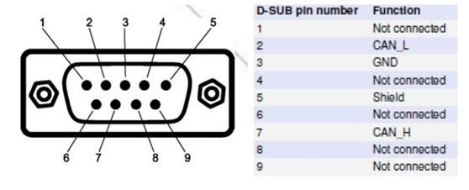

**Estonian National (valid until 31.12.2026)**

Injection must remain original.

**4.5.1 Cross Car Junior (XC Jr.) – Injection**

Homologated.

Only the engine mapping may be modified.

Only one ECU may be present in the vehicle; its location is free.

It is forbidden to install any electronic units other than a dashboard in the vehicle.

All other devices must only be passive sensors.

**4.5.2 Cross Car Junior (XC Jr.) – Dashboard**

Coming from a series model of motorbike fitted with the engine eligible in the XC Jr. category.

No modifications allowed.

**4.6 Ignition**

Homologated. The make and type of the spark plugs and leads are free. The use of ceramics for spark plugs is authorised.

**4.7 Dynamos, alternators, batteries**

Dynamos and alternators may be removed, but each car must have an on-board battery.

The use of any outside source of energy to start the engine of the car on the grid or during a race is forbidden.

**4.7.1 Cross Car Junior (XC Jr.) – Dynamos, alternators**

Homologated. The use of any outside source of energy to start the engine of the car on the grid or during a race is forbidden.

**4.8 Starting on board the car**

A starter with an electric or other source of energy on board, operable by the driver when seated in the seat, is mandatory.

The use of any outside source of energy to start the engine of the car on the grid or during a race is forbidden.

**4.9 Exhaust system**

The exhaust must conform to the homologated dimensions.

The dimension of the average length of the exhaust pipe tubes must be within the tolerances indicated in the Cross Car engine homologation forms.

It must include the homologated silencer and one of the catalytic converters listed in FIA Technical List n°8.

The exit of the exhaust pipe must be situated at the rear of the car, behind the wheel axis, at least 200 mm from the ground and within the perimeter of the car.

Exhaust pipe outlets which point downwards are prohibited.

4.9.1

Estonian National (valid until 31.12.2026)

A silencer must be used. The exhaust system may be modified or replaced. The exhaust must have a silencer. The exhaust pipe may extend a maximum of 100 mm beyond the car's body panels.

**4.9.1 Cross Car Junior (XC Jr.) – Exhaust System**

The exhaust system must conform with the following criteria:

• Material restricted to Steel and Inox 304 or 316.

• Minimal material thickness of 1.2 mm, measured at the uncurved parts.

• Maximum external diameter of the primary pipes of 38.1 mm.

•It must include the homologated silencer and one of the catalytic converters listed in FIA Technical List n°8.

The exit of the exhaust pipe must be situated at the rear of the car, behind the wheel axis, at least 200 mm from the ground, and within the perimeter of the car.

Exhaust pipe outlets which point downwards are prohibited.

**4.9.2 Catalytic Converters**

Inlet and outlet cones and fixing brackets of a homologated catalytic

converter may be added and/or modified.

**4.10 Heat shielding of the exhaust system**

Authorised:

• Directly on the exhaust system

• On components in close proximity to the exhaust system, and it must be removable only with the use of tools.

Adequate protection must be provided in order to prevent heated pipes from causing burns.

**4.11 Sound level**

A limit of 100 dB/A is imposed for all cars. The noise must be measured in accordance with the FIA noise measuring procedure using a sonometer regulated at "A" and "SLOW", placed at an angle of 45° to, a distance of 500 mm from and at the same height as the exhaust outlet, with the car’s engine running at 4500 rpm.

**4.12 Air box**

Homologated. No modifications are allowed.

Upstream of the air box, it is allowed to add one or more pipes (bonded and/or fixed with bolts to the air box) for the sole purpose of connecting external air filters without modifying the inlet section of the air box.

Original air filter may be removed.

**Estonian National (valid until 31.12.2026)**

Air box and air filter are free.

**4.12.1 Cross Car Junior (XC Jr.) – Air box**

Free.

**4.13 Intake manifold**

Homologated.

**4.14 Throttle body**

Homologated.

Should a second throttle body assembly not be controlled by the existing homologated ECU, it may be blocked in position.

**4.14.1 Cross Car Junior (XC Jr.) – Throttle body**

Homologated.

**4.14.2 Cross Car Junior (XC Jr.) – Restrictor**

All engines must be fitted with two restrictors fixed to the throttle unit entrance.

All the air necessary for feeding the engine must pass through these restrictors, which must respect Drawing 279B-16.

• The maximum internal diameter of the restrictors must be 26.2 mm.

• This diameter must be maintained for a minimum length of 6 mm.

• This diameter must be complied with, regardless of temperature conditions.

• The maximum length between the inlet of the restrictor and the throttle body is as defined in Drawing 279B-17.

• The external diameter of the restrictors is free.

The mounting of the restrictors onto the throttle unit must only be carried out with superclamps.

The heads of the screws of the superclamps must be pierced so that they may be sealed.

All restrictors must be made from a single material.

**4.15 Throttle**

There must be a proven means of closing the throttle in the event of failure of the throttle linkage, by means of an external spring operating on each throttle spindle or slide.

**4.16 Air filter**

Free as well as its position and numbers.

Combustion air must not be taken from inside the cockpit.

**4.17 Water radiator**

The water radiator and its capacity are free. Position of the coolant radiator:

Free but forbidden and not visible in the cockpit. It must be located inside the bodywork.

The air cooling lines upstream of the water radiator as well as the water pipes are free.

**4.18 Cooling system**

Water pump as homologated.

The thermostat is free, as is the control system and the temperature at which the fan cuts in.

The radiator cap and its locking system are free.

The expansion chamber is free, provided that the capacity of the new chambers does not exceed 2.5 litres.

The liquid cooling lines external to the engine block and their accessories are free.

Lines of a different material and/or diameter may be used. No part of the cooling system may be inside the cockpit.

The fans and their position are free, as are their electric looms.

At any time, the maximum distance between the rear face of the radiator core and the rearmost part of the cooling fan blades is 150 mm.

A duct may be fitted between the radiator core and the cooling fan.

Any system for spraying water onto the engine water radiator is prohibited.

**4.19 Engine oil cooling**

Oil pump as homologated.

The oil radiators and their connections are free, provided that they are situated within the perimeter of the bodywork.

No part of the cooling system may be inside the cockpit.

**4.20 Oil tanks, engine water expansion chambers, oil and water radiators**

They must be isolated from the cockpit by means of bulkheads so that in the case of leakage or failure of a tank / radiator, no liquid may enter into the cockpit.

Any tank containing oil must be situated in the main structure of the vehicle.

If the lubrication system includes an open type sump breather, it must be equipped in such a way that the oil flows into a catch tank (minimum capacity : 1 litre).

**4.21 Repairs**

It is possible to repair the following parts by welding:

• Cylinder head cover

• Cylinder head

• Engine block

• Oil pan

• Intake and exhaust manifolds

• Gearbox casing

The weld must be strictly limited to the repair area, must respect the shape and must not change the function or performance of the part.

A damaged dowel bore can be repaired using a bush with a maximum wall thickness of 4 mm, the length of which is no more than 2 mm greater than the original bore depth.

Damaged threads can be repaired by screwing on a new thread with the same interior diameter ("helicoil" type).

**4.22 Breathers**

Breathers may be removed and blanked.

**4.23 Chain Guard**

One (1) unused fastening protrusion of the chain guard on the engine block can be removed.

**ART.5 FUEL CIRCUIT**

**5.1 Fuel pumps (except high pressure pumps)**

Fuel pumps (including their number) are free provided that they are installed:

• either inside the fuel tank,

• or outside the fuel tank, protected by a leak-proof and flameproof cover and must be outside the cockpit.

The fuel pressure cannot be higher than the fuel pressure homologated with the engine.

Petrol filters with a maximum unit capacity of 0.5 l may be added to the fuel feed circuit.

**5.2 Fuel lines**

Flexibles lines must be of aviation quality.

The installation is free, provided that the prescriptions of Article 253- 3 of Appendix J are respected.

The automatic fuel cut-off system described in Article 253-3.3 is compulsory.

**Estonian National (valid until 31.12.2026)**

Fuel lines must be fixed safely with brackets.

**5.3 Fuel tank**

The fuel tank must be homologated to one of the following FIA standards:

FT3-1999, FT3.5-1999, FT5-1999.

It must be in accordance with the specifications of Article 253-14. The capacity of the fuel tank is free, provided that it complies with the conditions of the fuel sampling regulations.

The location of the fuel tank must respect the following conditions: Must not be located in the cockpit, must be situated behind the seat in side view and must be separated from the cockpit by a fireproof bulkhead.

Must be mounted in a sufficiently protected location inside the base construction structure and be firmly attached to the car.

The fuel tank must be isolated from the engine and the exhaust by a leak-proof, non-flammable metallic container with a minimum material thickness of 1.5 mm.

The fuel circuit must comprise only the following parts:

• One fuel supply outlet for the engine

• One fuel sampling connector

• One fuel return into the tank

• One breather in conformity with Article 253-3.4 of Appendix J

The storing of fuel on board the car at a temperature of more than 10° centigrade below the ambient temperature is forbidden

**Estonian National (valid until 31.12.2026)**

The fuel tank is free, but its volume must not exceed 12 litres. It is advisable to use a safety tank and a venting system. The tank must be securely fastened outside the cockpit. If the tank is located behind the main rollbar, the rollbar may be modified by 40 mm. If the tank is located elsewhere, it must be surrounded by a structure made of 30 mm diameter pipes. If the tank is located closer than 200 mm to the engine or silencer, it must be insulated with a heat-resistant screen. If the tank is located next to the driver, on the side of the car, it must be insulated from the cockpit with a liquid-proof metal screen.

It is prohibited to store fuel in the car at a temperature less than 10°C below the ambient temperature.

**5.3.1 Ageing of tanks**

The ageing of safety tanks entails a considerable reduction in the strength characteristics after approximately five years.

No bladder may be used more than 5 years after the date of manufacture, unless inspected and recertified by the manufacturer for a period of up to another two years.

In order to allow the checking of the validity expiry date, a leak-proof cover plate, minimum 1.5 mm thick, made from non-flammable material, easily accessible and removable only with the use of tools, must be installed in the protection for FT3-1999, FT3.5-1999 or FT5- 1999 tanks.

**5.4 Filling and venting**

The location of the filler caps or the two quick-action couplings for refuelling is free, but they must be leak-proof and must not protrude beyond the perimeter of the chassis and bodywork.

**5.5 Fuel sampling connector**

The car must be fitted with a self-sealing connector for sampling fuel.

This connector must be FIA approved (Technical List n°5) and be fitted on the fuel supply outlet for the engine.

The connector must be placed in a non-lockable area inside the engine compartment. It must be possible for a pipe to be fitted to this connector.

**ART. 6 ELECTRICAL EQUIPMENT**

**6.1 Wiring loom & Fuses**

Free.

**6.2 Circuit breakers**

Circuit breakers may be freely changed vis-à-vis their use, position, or number in the case of additional accessories.

**6.3 Launch control switch**

A launch control switch is prohibited.

**6.4 Battery(ies)**

Each car must have an on-board battery. Make and type of battery(ies):

The make, capacity and cables of the battery(ies) are free. Location of the battery(ies):

Its (their) location is free.

The battery must be of the dry type if it is in the cockpit.

Battery fixing:

Each battery must be securely fixed, and the positive terminal must be protected.

It must be attached to the body using a metal support and two metal clamps with an insulating covering, fixed to the floor by bolts and nuts.

For attaching these clamps, metallic bolts with a diameter of at least 6 mm must be used, and under each bolt, a counter- plate at least 3 mm thick and with a surface of at least 20 cm2 beneath the floor.

The securing system must be able to withstand a deceleration of 25 g.

Wet battery:

A wet battery must be covered by a leakproof cover, attached independently of the battery.

**6.5 Alternator / Generator / Starter**

Must remain as homologated with the engine.

**6.6 General circuit breaker**

The general circuit breaker must cut all electrical circuits, battery, alternator or dynamo, fuel pumps, lights, hooters, ignition, electrical controls, etc.) and must also stop the engine.

It must be a spark-proof model and must be accessible from inside and outside the car.

As for the outside, the triggering system of the circuit breaker must compulsorily be positioned on the lower part of the windscreen/metal grill mountings on the left side of the car. It must be marked by a red spark in a white-edged blue triangle with a base of at least 12 cm.

**6.7 Lights**

**Brake light:**

Each car must be fitted with a minimum of two red LED rear lights with a diameter of at least 80 mm (36 LEDs minimum) or with two rain lights approved by the FIA (FIA Technical List n°19) that work whenever the brakes are on.

They must be positioned between 1400 mm and 800 mm above ground level and must be visible from the rear.

They must be placed symmetrically in relation to the longitudinal axis of the car and in the same transverse plane.

**Rear light:**

Each car must be fitted with one red LED rear light with a diameter of at least 80 mm (36 LEDs minimum) or with a rain light approved by the FIA (FIA Technical List No. 19). It must be clearly visible from the rear, and it must be permanently switched on when the car is driving and must be positioned between 1400 mm and 800 mm above ground level.

It must be possible for the driver sitting at his steering wheel to switch them on.

Estonian National (valid until 31.12.2026)

Red LED brake lights must be located symmetrically on either side of the car's centre line. The minimum diameter or height of the brake lights is 50 mm, they must be located between 800 mm and 1400 mm above the ground. The brake lights must be connected to a light switch in the car's brake system.

There must also be one central red LED light. With a minimum diameter or height of 50mm. This light must be located between 800mm and 1400mm above the ground and must always be switched on.

These three lights must be positioned so that at least two of them are always visible from the rear of the car when viewed from an angle of 30° to either side of the car's centre line. The shape and aerodynamic devices of the car's bodywork must not restrict the visibility of these lights.

**ART.7 TRANSMISSION**

**7.1 Type of gearbox**

The engine integrated gearbox must not undergo any modifications compared to the homologated one unless such modifications are explicitly allowed by the present regulations.

The principle of changing gears by using paddles on the steering wheel or steering column is prohibited.

The transmission system must be activated and controlled only by the driver.

**7.2 Gearshift control**

Location / type: free.

The gear change mechanism must be manual, linked to a gear change lever directly by rods or cables only.

The gear lever must be fixed on the chassis and can be adjustable. No air, electrical or hydraulic assisted gear change system is allowed.

**7.3 Cut-off sensor for gear command**

Permitted.

**7.4 Transmission system**

Free, but the two rear wheels must be attached to the same shaft, which may have universal joints.

Any kind of differential is forbidden. A secondary chain drive is permitted. A reverse gear is recommended.

The reverse gear efficiency check is carried out as follows:

• A load cell is attached to a stable fixed point in the scrutineering area.

• An adequate rope/strap is attached to the load cell.

• The other end of the rope/strap is fixed to the front end of the vehicule.

The measuring method must be as follows:

• Surface must be asphalt.

• The vehicule must pull the load cell in reverse gear a certain amount.

Rear axle drive unit:

If the car is equipped with a rear axle type drive unit, the competitor must have a technical form describing the operating principle and the number of teeth of the different gears.

Traction control is prohibited.

**7.5 Clutch**

The series production clutch, homologated with the engine, must be kept; only the friction discs and/or the springs can be replaced.

The parts used must be able to be fitted in place of the original parts without any modification.

The clutch must be exclusively operated and controlled by the foot of the driver.

A centrifugal assisted clutch can be used if it is the model homologated with the engine.

The centrifugal assistance homologated with the engine can be blocked in order to make it inoperative.

**7.6 Master-cylinder**

Free.

**7.6.1 Clutch fluid tank**

If inside the cockpit, it must be securely fastened and be protected by a leak-proof and flameproof cover or must be made out of metallic material.

**7.7 Transmission shafts**

Transmission shafts are free but must be made of steel.

In addition, the joints must be derived from a manufacturer’s model of automobile produced in a quantity of more than 2,500 units (may be modified).

**7.8 Sensors**

Any sensor, contact switch or electric wire on the four wheels and gearbox is forbidden.

A gear cut sensor is allowed. Exception:

Only one sensor for displaying the speed of one front wheel is allowed.

**ART.8 SUSPENSION**

**8.1 General**

It is forbidden to use active suspension (any system which allows control of flexibility, damping, height and/or attitude of the suspension when the car is in motion).

**8.2 Joints (wishbones/links and suspension parts)**

Rubber, ball joint, plain bearing, bearings (ball, roller, needle): free.

**8.3 Suspension system**

Cars must be fitted with a sprung suspension.

The operating method and the design of the suspension system are free.

The use of active suspension is forbidden.

Coil springs are compulsory. The number is free. They must be made from steel alloy.

Suspension parts made partially or entirely from composite materials are prohibited.

**8.4 Shock absorbers**

Only one shock absorber per wheel is authorised.

Only maximum three-way adjustment systems are permitted.

Only non-adjustable hydraulic bump stops are permitted. Roll control systems are prohibited.

All shock absorbers must be independent of each other. Inertia shock absorber systems are prohibited.

The checking of the operating principle of the shock absorbers must be carried out as follows :

Once the springs are removed, the car must sink down to the bump

stops in less than 5 minutes.

With regard to their principle of operation, gas-filled shock absorbers

are considered as hydraulic shock absorbers.

If the shock absorbers have separate fluid reserves located in the cockpit, these (including hoses and joints) must be securely fastened and be protected by a liquid-proof and flameproof cover.

A suspension travel limiter may be added.

Only one cable per wheel is allowed, and its sole function must be to limit the travel of the wheel when the shock absorber is not compressed.

Water cooling or heating systems are prohibited.

Whatever the type of the shock absorbers, the use of ball or roller bearings with linear guidance is prohibited.

Changes to the spring and shock absorber settings from the cockpit are prohibited.

The adjustment of the springs and/or shock absorbers from the cockpit is forbidden.

It must only be possible when the car is not in motion and only with the use of tools.

The adjustment device must be situated on the shock absorber or its gas reserve.

Any connections between dampers are forbidden; the only connections permitted are the damper fixing points passing through the frame; these must have no other function.

**8.5 Antiroll bars**

They must respect the following:

• Their operating principle must be solely mechanical.

• The antiroll bars and their links must be made from metallic material and must not be adjustable from the cockpit.

• Under no circumstances may the antiroll bars be connected to one another.

**ART.9 WHEELS AND TYRES**

**9.1 Wheels**

The rims must have a maximum diameter of 10” and a maximum width of 6” at the front and 8” at the rear.

Rims must be made from either iron-based alloy or aluminium alloy.

Beadlock type rims are permitted.

Beadlock rings are free but must be in conformity with the following:

• Maximum outer Ø: 300 mm

• Minimum inner Ø: 175 mm

• Material: either iron-based alloy or aluminium alloy

• No part of the beadlock ring and its attachment may protrude beyond the vertical plane of the outermost part of the tyre.

**9.2 Wheel attachment**

Central wheel nut fixation systems are prohibited. No part of the wheel attachment (wheel studs and wheel nuts) may protrude beyond the vertical plane of the outermost part of the rim.

**9.3 Tyres**

The complete wheel (flange + rim + inflated tyre) must always fit inside a U-shaped gauge of which the extremities are 260 mm apart, the measurement to be made on an unloaded part of the tyre.

Any modification – retreading, mechanical or chemical treatment – is prohibited.

Any means of warming the tyres – tyre blankets, ovens, roller systems, etc. – is prohibited.

**9.3.1 Pressure control valves**

Pressure control valves on the wheels are forbidden.

**9.4 Wheel trims**

Wheel trims are forbidden.

**9.5 Air extractors**

The fitting of air extractors on the wheels is prohibited.

**ART. 10 BRAKING SYSTEM**

**10.1 Brakes**

Free, but must comply with Article 253-4 of Appendix J. Brake lines must comply with Article 253-3 of Appendix J.

A hydraulic handbrake system is authorised; it must be efficient and simultaneously control the two front wheels or the two rear wheels.

A central braking system on the rear axle is permitted. Brake discs must be made from iron-based alloy.

Carbon brake discs are forbidden.

**10.2 The braking system is free, provided that:**

• It is activated and controlled only by the driver

• It includes at least two independent circuits operated by the same pedal (between the brake pedal and the callipers, the two circuits must be separately identifiable, without any interconnection other than the mechanical braking force balancing device)

• The pressure is identical on the wheels of the same axle, with the exception of the pressure generated by the handbrake

Components of the braking system:

• The callipers must come from a series vehicle or from a catalogue of competition parts with a maximum of 4 pistons.

• discs must come from a series vehicle or from a catalogue of competition parts.

• Master-cylinders: Free

• Proportional valve: Free

• Pedal box: Free

**10.3 Brake fluid tanks**

If inside the cockpit, they must be securely fastened and be protected by a leak-proof and flameproof cover or must be made out of metallic material.

**ART.11 STEERING**

**11.1 Wheel steering**

The link between the driver and the wheels must be mechanical and continuous.

4-wheel steering is prohibited.

**11.2 Steering mechanism**

The steering mechanism and its position are free.

Flexible steering controls by e.g. chain, cable, etc. are prohibited.

**11.3 Steering rods / Steering joints**

Free.

**11.4 Steering column**

Free, but it must be fitted with a retractable device in case of impact. The retractable part must derive from a series vehicle and must have a minimum travel of 50 mm.

**11.5 Support / steering column**

Free.

**11.6 Steering wheel**

The steering wheel must be fitted with a quick release mechanism. This mechanism must consist of a flange concentric to the steering wheel axis, coloured yellow and installed on the steering column behind the steering wheel.

The release must be operated by pulling the flange along the steering wheel axis.

Controls and buttons on the steering wheel are prohibited.

**11.7 Power steering**

Any power steering system is forbidden.

**ART.12 CHASSIS**

The multi-tubular space frame structure formed by the compulsory base construction of the safety cage, compulsory reinforcement tubes and any other tubular structure or elements welded together for the functioning of the car, must be considered as “the chassis”.

Chassis must meet the requirements Art 12.2 - 12.4.4.

**Estonian National (valid until 31.12.2026)**

**12.1 General**

The chassis must meet the requirements Art 12.4.5.

**12.1 General**

The fitting of a safety cage is compulsory.

a) In all cases, it must be fabricated in compliance with the requirements of the following articles;

b) It must be homologated or certified by an ASN in compliance with the requirements of the following articles.

Any cage which is homologated or certified by an ASN must be identified by means of an identification plate affixed to it by the manufacturer; this identification plate must be neither copied nor moved (e.g. embedded, engraved, metallic plate).

The identification plate must bear the name of the manufac- turer, the homologation or certification number of the ASN homologation form or certificate and the individual series number of the manufacturer.

An authentic copy of the homologation document or certificate bearing the same numbers, approved by the ASN and signed by qualified technicians representing the manufacturer, must be presented to the competition’s scrutineers.

Any modification to a homologated or certified safety cage is forbidden.

**Exceptions:**

1. Adding, removing, or modifying specific brackets e.g. bodywork brackets, handbrake brackets, gear lever brackets, electric loom brackets, fuel line brackets, pedal box brackets, ballast brackets are permitted.

Any of these modifications must be carried out by the manufacturer of the safety cage, or with its approval.

2. Any other modifications carried out by the manufacturer of the safety cage must be documented in an Option Variant (VO) of the Safety Cage Certificate.

The modifications on the homologated chassis must not entail any variation of the length, geometry or tube dimensions of the compulsory members that are indicated in the chassis drawing of the Safety Cage Certificate.

To be considered as a modification: any operation carried out on the cage by machining or welding that involves a permanent modification of the material or the safety cage.

All repairs to a homologated or certified safety cage, damaged after an accident, must be carried out by the manufacturer of the cage or with his approval.

**12.2 Definitions**

**12.2.1 Safety cage**

Multi-tubular structure installed and welded to the chassis been an integral part of it, the function of which is to reduce the deformation of the cockpit in case of an impact.

**12.2.2 Rollbar**

Tubular frame forming a hoop with two mounting feet.

**12.2.3 Main rollbar** (Drawing 279B-3)

Transverse and near-vertical (maximum angle +/-10° to the vertical) single piece tubular hoop located across the car just behind the driver’s seat.

The tube axis must be within one single plane.

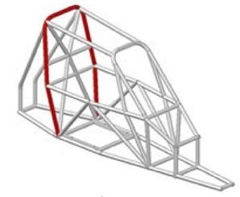

Drawing 279B-3

**12.2.4 Front rollbar** (Drawing 279B-4)

Similar to the main rollbar but located in front of the driver’s seat at windscreen level.

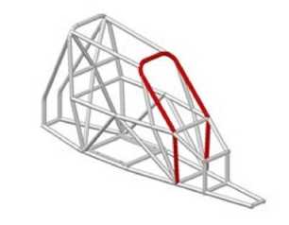

Drawing 279B-4

**12.2.5 Lateral half-rollbar** (Drawing 279B-5)

Lateral rollbar without the rear pillar.

Near-longitudinal and near-vertical single piece tubular hoop located along the right or left side of the vehicle.

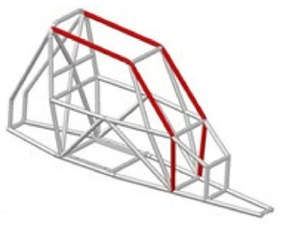

Drawing 279B-5

**12.2.6 Longitudinal member** (Drawing 279B-6)

a) Near-longitudinal single piece tube joining the upper parts of the front and main rollbars.

b) Near-longitudinal single piece tube joining the mounting feet of the rear backstays, main rollbar, lateral half-rollbar or front rollbar and ending in front of the pedal box frame.

The maximum permitted angle of the longitudinal member to the X axis in X/Y plane is ±45°.

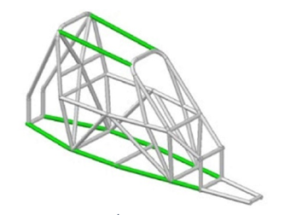

Drawing 279B-6

**12.2.7 Transverse member** (Drawing 279B-7)

a) Near-transverse single piece tube joining the upper parts of the lateral half-rollbars.

b) Near-transverse single piece tube joining the 2 mounting feet of the front rollbar, of the main rollbar, of the backstays, or the 2 front and rear ends of the lower longitudinal members.

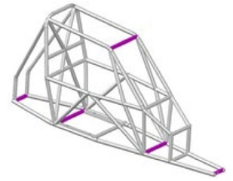

Drawing 279B-7

**12.2.8 Diagonal member** (Drawing 279B-8)

Transverse tube between: One of the top corners of the main rollbar, and the lower mounting point on the opposite side of the rollbar.

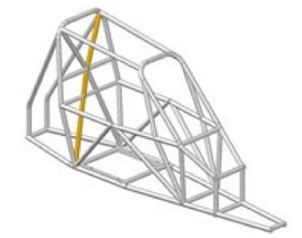

Drawing 279B-8

**12.2.9 Removable members**

Members of a safety cage which must be able to be removed.

**12.2.10 Cage reinforcement**

Member added to the safety cage to improve its strength.

**12.2.11 Mounting foot**

End of a rollbar tube to permit its welding to the chassis.

**12.2.12 Gusset (Drawing 253-34)**

Reinforcement for a bend or junction made from bent sheet metal with a U shape the thickness of which must not be less than 1.0 mm.

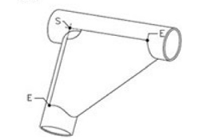

Drawing 253-34

The ends of this gusset (point E) must be situated at a distance from the top of the angle (point S) of between 2 and 4 times the outer diameter of the biggest of the tubes joined.

A cut-out is permitted at the top of the angle, but its radius (R) must be no greater than 1.5 times the outer diameter of the biggest of the tubes joined.

The flat sides of the gusset may have a hole the diameter of which must not be greater than the outer diameter of the biggest of the tubes joined.

**12.3 Assembly of the safety cage**

The safety cage must be welded onto the structure to which the suspension loads are transmitted (with, if necessary, additional reinforcement at the joint between the chassis and the foot of the rollbar).

The mounting points of the front, lateral half and main rollbars must be situated at least at the level of the cockpit floor. The chromium plating of all or part of the cage is forbidden. Tubes must not carry fluids or any other item.

The safety cage must not unduly impede the entry or exit of the driver.

**12.4 Specifications**

**12.4.1 Base construction**

The base construction must be made according to one of the two (2) following designs:

12.4.1.1 Base construction 1 (Drawing 279B-1)

• 1 main rollbar

• 1 front rollbar

• 2 longitudinal members joining the upper part of the main and front rollbars

• 2 backstays with 2 near-vertical extensions (maximum angle ± 10° to the vertical) of the same section and quality going down to the floor level and to the rear end of the car

• 2 longitudinal side members joining the vertical extensions to the backstays, main rollbar and front rollbar, ending in front of the pedal box frame

• 4 transverse members connecting the vertical extensions to the backstays, main rollbar, front rollbar and the front ends of the two lower longitudinal side members

• 2 transverse members connecting each side of the main rollbar, 1 at the height of the doorbars (see Article 12.4.2.1.2) and a second one for the safety harnesses (see Article 14.3.2)

• Pedal box frame

• Door bars

• Diagonal member (see article 12.4.2.1.1)

• Windscreen pillar reinforcement

• Transverse member on the front rollbar (Drawing 279B-12)

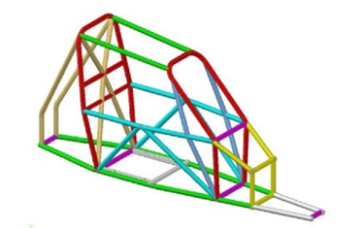

Drawing 279B-1

**12.4.1.2 Base construction 2** (Drawing 279B-2)

• 1 main rollbar

• 2 lateral half-rollbars

• 1 transverse member joining the upper part of the lateral half- rollbars

• 2 backstays with 2 near vertical extensions (maximum angle ± 10° to the vertical) of the same section and quality going down to the floor level and to the rear end of the car

• 2 longitudinal side members joining the vertical extensions to the backstays, main rollbar and lateral half-rollbar, ending in front of the pedal box frame

• 4 transverse members connecting the vertical extensions to the backstays, main rollbar, front rollbar and the front ends of the two lower longitudinal side members

•2 transverse members connecting each side of the main rollbar, 1 at the height of the doorbars (see Article 12 .4.2.1.2) and a second one for the safety harnesses (see Article 14.3.2)

• Pedal box frame

• Door bars

• Diagonal member (see Article 12.4.2.1.1)

• Windscreen pillar reinforcement

• Transverse member on the front rollbar (Drawing 279B-12)

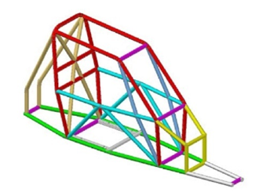

Drawing 279B-2

**12.4.1.3** The vertical part of the main rollbar must have only one bend between its lower part and its upper part.

The pillar of a front rollbar (or the front pillar or half-rollbar) must have only one bend between its lower part and its upper part.

The angle between the lower part of the front rollbar and the longitudinal side member must be 90° ±1°.

The following connections must be situated at the roof level:

• Longitudinal members to the front and main rollbars

• Lateral half-rollbar to the main rollbar

• The backstays must be attached at the roof level and near the top outer bends of the main rollbar, on both sides of the car

**12.4.1.4 Removable members**

Only the base construction and optional members of the safety cage mounted behind the main rollbar may be made with removable

members.

Dismountable joints are authorised in order to allow the use of removable members

They must be homologated by the FIA (list in Homologation Regulations for Safety Cage appendix).

Dismountable joints homologated by an ASN are also authorised in the following conditions (list in HR for SC appendix):

• The joints must meet the FIA test procedure in appendix;

• The reference of the test report must be mentioned on the ASN homologation form / certificate of the cage;

• The dismountable joints used on a cage homologated/certified by an ASN must be detailed (photographs/drawings) on the ASN homologation form / certificate of the cage.

They must not be welded once assembled.

**12.4.2 Design**

Design is free, as long as it includes all the mandatory members defined in Articles 12.4.1.1 and **12.4.1.2.** Once the base construction is defined, it must be completed with compulsory members and reinforcements (see Article 12.4.2.1), to which optional members and reinforcements may be added.

Unless explicitly permitted, all members and tubular reinforcements must be single pieces.

**12.4.2.1 Other compulsory members**

**12.4.2.1.1 Diagonal member** (Drawing 279B-9)

The cage must have two diagonal members on the main rollbar according to Drawing 279B-9.

Members must be straight.

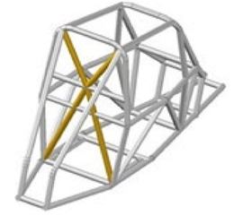

Drawing 279B-9

**12.4.2.1.2 Doorbars** (Drawing 279B-10)

Longitudinal members must be fitted on each side of the car according to Drawing 279B-10.

The design must be identical on both sides.

The side protection must be as high as possible, but its upper attachment point must not be higher than half the height of the lateral cockpit opening measured from its base.

The lower attachment points of the members must be fitted directly onto the longitudinal side members, less than 100 mm from the junctions between the mounting points of the front rollbar / lateral half rollbars / main rollbar and the longitudinal side members.

The connection of the doorbars to the windscreen pillar rein- forcement (Drawing 279B-11) is compulsory.

If the doorbars and the windscreen pillar reinforcement are not situated in the same plane, the reinforcement may be made of fabricated sheet metal, provided it complies with dimensions in **Article 12.2.12.**

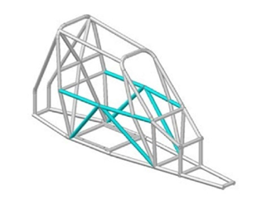

Drawing 279B-10

**12.4.2.1.3 Windscreen pillar reinforcement** (Drawing 279B-11)

It must be fitted on each side of the front rollbar (Drawing 279B-11). It may be bent on condition that it is straight in side view (maximum angle 30° to the vertical) and that the angle of the bend does not exceed 20°.

Its upper end must be less than 100 mm from the junction between the front (lateral) rollbar and the longitudinal (transverse) member.

Its lower end must be at the (front) mounting foot of front (lateral) rollbar.

If this reinforcement intersects the doorbars, it must be divided into several parts.

If the door bars and the windscreen pillar reinforcement do not intersect each other, a specific reinforcement made of fabricated sheet metal is compulsory (Drawing SC-GU-3).

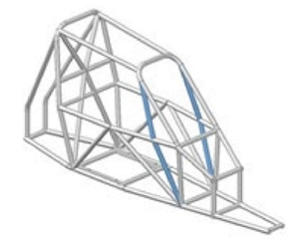

Drawing 279B-11

12.4.2.1.4 Transverse member on the front rollbar (Drawing 279B-12)

The transverse member fixed to the front rollbar must not encroach upon the space reserved for the driver.

It may be placed as high as possible, but its lower edge must not be positioned below the steering column.

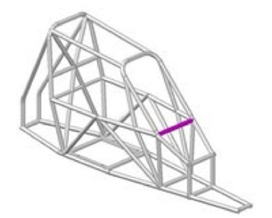

Drawing 279B-12

**12.4.2.1.5 Pedalbox-frame** (Drawing 279B-13)

Tubular frame forming a protection around the pedal box.

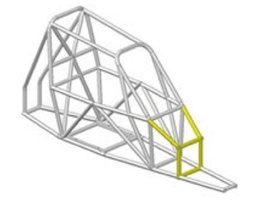

Drawing 279B-13

**12.4.2.1.6 Backstays** (Drawing 279B-15)

Two backstays with two near-vertical extensions (maximum angle ± 10° to the vertical) of the same section and quality going down to the floor level and to the rear end of the car.

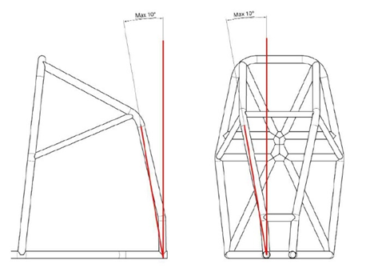

Drawing 279B-15

**12.4.3 Tube specifications**

Only tubes with a circular section are authorised. Specifications of the tubes used:

|  |  |  |  |
| --- | --- | --- | --- |
| **Min. material spec.** | **Min. tensile strength** | **Minimum dimensions (mm)** | **Use** |
| Cold drawn seamless  unalloyed carbon steel  (or other - see below)  containing a maximum of  0.3 % of carbon | 350 N/mm2 | 40 x 2 mm | Main rollbar  Front rollbar or  Lateral half-rollbar  2 transverse members fitted to  the main rollbar  (material: see article 14.3.2) |
| 40 x 1,5 | Other parts of the safety cage  (unless otherwise indicated in  the articles above) |

**NOTE:**

For unalloyed steel, the maximum content of additives is 1.7% for manganese (mn) and 0.6% for other elements.

For alloyed steel, the maximum content of additives is:

C = 0.29 %; Si = 0.4 %; Mn = 0.9 %; Cr = 1.2 %; Mo = 0.3 %; other elements = (Pb)

In selecting the steel, attention must be paid to obtaining good elongation properties and adequate weldability.

The tubing must be bent by a cold working process and the centreline bend radius must be at least 3 times the tube diameter. If the tubing is ovalised during bending, the ratio of minor to major diameter must be 0.9 or greater.

The surface at the level of the bends must be smooth and even, without ripples or cracks.

**12.4.4 Guidance on welding**

Welding must be carried out along the whole perimeter of the tube. All welds must be with full penetration and preferably using a gas- shielded arc.

When using heat-treated steel the special instructions of the manufacturers must be followed (special electrodes, gas protected welding).

**Estonian National (valid until 31.12.2026)**

**12.4.5 Frame**

Frame must be made from tubes manufactured from steel with minimum dimensions 30 x 2 mm or square shape steel material with shortest side at least 30 mm and the wall thickness at least 2 mm. Diagonal or straight tubes with a minimum outer diameter of 20mm and a wall thickness of 2mm are permitted at the front of the frame.

A safety cage is mandatory. It must consist of drawn tubes with a strength of at least 350 Nm/mm². The cage must be attached to the frame at a minimum of six points. The cage must comply with one of the drawings AC001, AC002, AC003. A diagonal member must be installed to support the main rollbar according to drawing AD004, it must be a tube with a minimum diameter of 30 mm and a wall thickness of 2 mm. This diagonal may be removable. Alternatively, drawings AP001, AP002, AP003 or AP004 may be used. When using the tube marked in red on drawing AP004, the blue diagonal below it must not be installed.

All attachment points between the frame and the safety cage must be reinforced. It is prohibited to drill into the safety cage. All additionally installed reinforcement beams must have a minimum diameter of 20 mm and a wall thickness of 2 mm.

A tube can be added behind the seat to attach the safety harness.

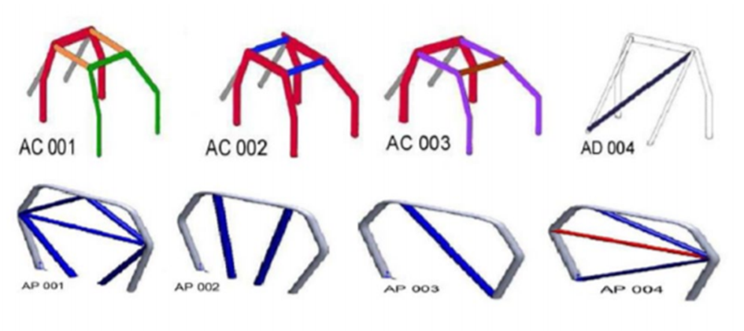

**12.4.6 Protective padding**

All tubes of the safety cage marked in red on Drawing 253-68 must be fitted with paddings in compliance with FIA Standard 8857-2001 type A (see Technical List n°23).

Each padding must be fixed in such a way as to prevent it from moving on the tube.

The only cutouts which may be carried out on the compulsory roll cage paddings are those that are necessary for its fitting to the tubes of the safety cage marked in red (to prevent interference with the roof panel and/or engine bulkhead).

If the engine bulkhead is fitted to the main roll bar on the cockpit side, the padding can be fitted to the bulkhead in front of the upper section of the main roll bar.

Where the driver’s body could come into contact with the safety cage, flame-retardant padding is recommended for protection.

**Estonian National (valid until 31.12.2026)**

The parts of the roll cage near the driver's helmet must be covered with soft material.

**12.5 Cockpit**

**12.5.1 Dimensions**

The width of the cockpit, maintained over 500 mm from the rearmost point of the seat in a horizontal plane towards the front, must not be less than 600 mm measured at the mid-point of the vertical height of the cockpit.

The location provided for the seat must have a minimum width of 450 mm maintained over the complete depth of the seat.

The minimum vertical height of the safety cage is 1050 mm between the cockpit floor (at seat location) measured at a point 300 mm forward of the lowest point of the main rollbar (cockpit side) and a line joining (on the outside of the cockpit) the two main rollbar and the front rollbar or the main rollbar and the transverse member between the lateral half rollbars.

The two safety rollbars must be high enough for a line extended from the top of the main rollbar to the top of the front rollbar (or tranverse member between lateral half-roll- bars) to pass at least 50 mm over the top of the driver’s helmet when he is seated normally in the car with his helmet on and his safety harness fastened.

**12.5.2 Pedal box**

The axis of the pedal box must be situated behind or directly above the axis of the front wheels.

Furthermore, the driver’s feet must be located at all times aft of the vertical plane passing through the front axle centreline.

The minimum width of the footwell must be 250 mm, maintained to a height of 250 mm, measured horizontally and perpendicularly to the longitudinal axis of the chassis directly above the pedals.

**12.5.3 Floor**

The floor of the cockpit extended to the front of pedal box must be closed with a metallic sheet, minimum thickness 1.5 mm.

The rear floor part of the chassis can be covered with a metallic sheet.

The metallic sheet must be securely fixed to the chassis with steel bolts.

**Estonian National (valid until 31.12.2026)**

The lower half of the bodywork must be completely covered from the front to the main frame. A minimum of 1 mm thick iron plate or a minimum of 2 mm thick aluminium plate can be used for the covering.

**12.5.4 Roof**

A rigid roof panel made from steel sheet, minimum 1.5 mm thick, above the driver is mandatory.

The panel may be fixed by welding to the safety cage tubes, or with a minimum of 6 M6 mm metallic bolts. The panel fixation brackets must be welded to the safety cage tubes.

If the welded panel or the fixation brackets have to be repaired, the work can only be done by the chassis safety cage manufacturer.

**Estonian National (valid until 31.12.2026)**

The roof of the car must be covered with a plate. The plate must be at least 1,5 mm thick, made of iron and welded to the roof of the car. The plate can be attached with a minimum of 20 welding point, each 20 mm long.

The minimum distance between the driver's helmet and the roof plate is 50 mm, measured with the driver sitting in the seat and the seat in the racing position.

**12.5.5 Internal parts**

No mechanical part other than the controls necessary for driving the vehicle may be situated in the cockpit.

No part of the cockpit, or situated in the cockpit, may have sharp or pointed parts.

Particular care must be taken to avoid any protrusion which could injure the driver.

**12.5.6 Cockpit - lateral openings**

The car must have lateral openings on both sides of the cockpit allowing the exit of the driver.

The cockpit must be designed so as to allow the driver to exit it from his normal position in the car within 7 seconds.

For the purpose of the above tests, the driver must be wearing all his equipment in accordance with Chapter 3 of Appendix L to the Code, the seat belts must be fastened, the steering wheel must be in place and in the most inconvenient position and the openings must be closed.

These openings must be closed completely to prevent the passage of a hand or arm.

The closing must be made of a steel grill with a maximum mesh of 25 mm x 25 mm, with a wire diameter or steel sheet thickness that is a minimum of 1 mm and a maximum of 2 mm.

At the top, this steel grill must be fixed to the safety cage by two hinges allowing the grill to be swung upwards to a vertical position.

At the bottom, this steel grill must have a locking device. The locking device’s latch must be fixed to the:

- door bar, or

- windscreen pillar reinforcement tube, or

- gusset of the windscreen pillar reinforcement.

The parts of the locking device must be made of steel.

The locking device must be built in such a way:

- that it can be opened from outside and inside the car;

- that it cannot be opened or open accidentally.

**Estonian National (valid until 31.12.2026)**

It is permitted to install polycarbonate glass and/or metal grill on the side doors.

The polycarbonate must be transparent so that the driver can be seen.

It is permitted to install covers on the side windows, but at least 2/3 of the upper edge of the window must remain transparent.

If a combination of grill and glass is used on the side doors, the glass does not have to completely cover the window opening.

The side window must be attached to the car frame at the top and attached to the bottom with quick-release fasteners that can be opened from both inside and outside the car.

Steel grill with a maximum mesh 40 x 40 mm, with a mesh wire of at least 3 mm or maximum mesh 60 x 60 mm, with a mesh wire of at least 2 mm.

If a grill and glass are used together, the glass must be placed on top of the grill.

**12.5.7 Lateral cockpit protection**

The copckit must have a lateral protection, covering the space between the upper part of the top lateral doorbars to the floor level, and from the main rollbar to the most forward point of pedal box.

This protection must consist of a minimum 1.5 mm thick metallic sheet or a minimum 2.5 mm thick Kevlar or carbon- Kevlar panel, securely fixed on the external face of the safety cage, using welded steel brackets.

The lateral cockpit protection can be part of the bodywork.

**12.5.7.1** In case a rocker arm type front suspension is used, a steel sheet, minimum thickness 1.5 mm, must separate the cockpit from the rocker arm suspension parts, including the shock absorbers.

The steel sheet must be fixed on at least 4 welded steel brackets, minimum thickness 2 mm, using at least 4 M6 steel bolts.

**12.5.8 Lateral anti-locking wheel protection**

Additional to that a tube structure which must conform to the material specifications given in Article 253-8.3.3 of 2020 Appendix J, with the exception of the dimensions of the tubes, which must measure at least 30 x 2 mm, must be fixed to the base construction of the car.

This structure must not have any sharp corners.

The outermost part of the protection must be situated at the level of the centre of the wheel hubs, over a minimum length of 60% of the wheelbase.

This protection must extend outwards on both sides at least as far as the vertical planes passing through the middle of the foremost part of the rear tyres and through the middle of the rearmost part of the front tyres, but not further than the vertical planes passing through the outside of the foremost part of the rear tyres and through the outside of the rearmost part of the front tyres.

**Estonian National (valid until 31.12.2026)**

A protective frame must be installed on the sides of the car. This frame must be made of steel tubes with a diameter of 30 mm and a wall thickness of 2 mm. The frame can be supplemented with 20 mm diameter and 2 mm wall thickness (alternatively 25 x 1,5 mm) tubes to attach the frame to the car. The frame must cover a minimum of 60% of the car's wheelbase. The area between the frame and the car body must be protected in such a way that it is impossible for another car's wheel to enter it. The ends of the outer beam must be closed with the same material, and the beam must be located at the height of the car's axle centerlines (+/-50 mm). (Valid until 2027)

**12.5.9 Fireproof bulkhead**

A fireproof and liquid-proof metallic bulkhead must separate the cockpit from the engine compartment.

Behind the driver’s seat the bulkhead must be located from the floor up to the roof.

From the floor to the height of the door bars, the bulkhead must be made of steel sheet with a minimum thickness of 1,0 mm. The remaining part of the bulkhead can be made of metallic material with a minimum thickness of 0,8 mm.

The bulkhead must be securely fixed to the chassis with M6 steel bolts.

Any object of a dangerous nature (inflammable products, etc.) must be carried outside the cockpit.

**Estonian National (valid until 31.12.2026)**

There must be a bulkhead between the driver and the engine compartment to protect the driver from high-temperature fluids and possible engine failure.

ART.13 BODYWORK

All parts of the bodywork must be carefully and fully finished, with no temporary or makeshift parts and no sharp corners.

No part of the bodywork may present sharp edges or points.

All parts having an aerodynamic influence and all parts of the bodywork must be secured rigidly to the completely sprung part of the car (chassis/body unit), must not have any degree of freedom, must be securely fixed and must remain immobile in relation to this part when the car is in motion except the driver’s ventilation sliders / scoops.

**13.1 Front and side bodywork**

Bumpers are prohibited.

The bodywork must cover the front part of the chassis entirely.

At the front and at the sides there must be hard, opaque bodywork providing protection against stones.

At the front, this bodywork must rise at least to the level of the centre of the steering wheel, and its height must not be less than 42 cm measured from the driver’s seat mounting.

The height of the side bodywork must not be less than 42 cm, measured in relation to the plane passing through the driver’s seat mounting.

**Estonian National (valid until 31.12.2026)**

The bodywork must cover the front part of the frame to the centre line of the steering wheel. The sides must be a minimum of 300 mm from the lower edge of the frame. The material must be at least 0,5 mm thick. Driver’s ventilation sliders are permitted and may be movable. (Valid until 2027)

**13.2 Rear bodywork**

All mechanical elements necessary for propulsion (engine, transmission, excluding the driveshafts) must be covered by the bodywork or mudguards.

Seen from above, all parts of the engine must be covered by sturdy, hard and opaque bodywork; the sides of the engine may be left uncovered.

From the outer perimeter of the bodywork, direct access to fan blades must be prevented either by being installed within the bodywork or by installing protection grilles.

**13.3 Rear view mirrors**

An external rear-view mirror must be present on each side of the car. The reflecting surface of each of these rear-view mirrors must not be less than 90 cm2, and it must be possible to fit into this surface a square with sides measuring 6 cm.

**13.4 Aerodynamic devices**

Front aerodynamic devices are prohibited.

A rear aerodynamic device may be allowed under the following conditions:

• It must be composed of just one wing (aerofoil profile), optional endplates and its supports.

• The material wing, its endplates and the supports is free within the limits of Article 279B-2.2.

• The wing must be made in one single piece and without any type of adjustments or any additional or dismountable elements

• The shape of the supports is free.

• The wing must be fixed to the supports.

• The supports must be fixed either to the bodywork or the chassis.

• The total width of the device in Y direction must not be more than 1080 mm

**13.5 Windscreen**

Must be made of polycarbonate or be a metal grill. Polycarbonate windscreen:

The thickness must not be less than 4,75 mm.

Cars with windscreens which are damaged to such an extent that visibility is seriously impaired or that there is a likelihood of their breaking further during the competition will be rejected.

Windscreens must not be tinted. Steel grill:

The windscreen may be replaced, or protected, by a steel grill covering the entire surface of the windscreen opening. The mesh size must be between 10 mm x 10 mm and 25 mm x 25 mm, and the diameter of the wire or steel sheet thickness of which the mesh is formed must be a minimum of 1 mm and a maximum of 2 mm.

In cars which have a windscreen, or which have the steel grill defined above, motorcycle type goggles or a visor fitted on the helmet must be worn by the driver.

Blanking material in the windscreen and windows may be accepted, on condition that it is properly fixed, and located only over a horizontal plane passing through the driver’s helmet visor’s highest point, when seated normally and with the seatbelts tightened.

Apertures of a total area not exceeding 64 cm² may be made in the windscreen.

**13.5.1 Windscreen wipers, motor and mechanism**

Free.

**13.5.2 Windscreen washer tank**

The capacity and the position of the windscreen washer tank are free.

The pumps, lines and nozzles are free.

**13.6 Competition number**

This must be displayed once on each side of the car and on each side of a panel on the roof or on the engine bonnet.

The car must bear no other number likely to be confused with it.

The roof number must be permanently fixed on a vertical support, maximal size 24 cm x 35 cm, with no sharp edges and must be positioned along the longitudinal axis of the car.

The number must be:

- in Arial Black font,

- vectorised for the following size: 18 cm x 31 cm.

**ART. 14 SAFETY EQUIPMENT**

**14.1 Safety - General**

Safety equipment must be used in its homologation configuration without any modification or removal of parts, and in conformity with the manufacturer's instructions.

**14.2 Driver’s seat**

A complete, FIA-homologated seat is mandatory (8855-1999, 8855- 2021 or 8862-2009 standards).

This seat may not be modified in any way.

The driver’s seat backrest may be tilted backwards by a maximum of 15° to the vertical.

**14.2.1 Anchorage points for fixing the seat supports**

**Estonian National (valid until 31.12.2026)**

The seat must be fixed at four points with bolts with a minimum diameter of 8 mm. The minimum thickness of steel used for seat attachments is 3 mm, lightweight materials are prohibited. The seat supports must be attached to the frame. The anchorage points must not be located on the floor of the vehicle. The supports must be attached to the frame by welding or bolts. The seat must have an integrated headrest. It must not be possible to change the seat position while driving.

The seat supports must be fixed on anchorage points for fixing seats in conformity with Construction “C” or “D” shown below, but instead of bolting the cross members to the base construction the crossmembers must be welded to the car base construction cross-wise or length-wise.

Installation proposals

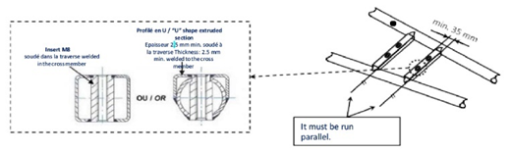

Construction “C”

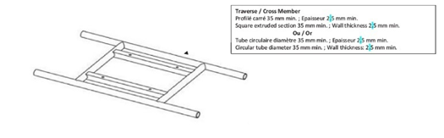

Construction “D”

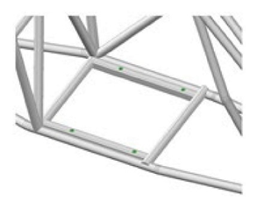

**14.2.2 Seat supports**

The seat supports must be fixed to the anchorage points for fixing seats via at least 4 mounting points per seat, using bolts measuring at least 8mm in diameter.

Articles 253-16.4 to 253-16.5 of Appendix J are also applicable.

**14.3 Safety harness**

Estonian National (valid until 31.12.2026)

A minimum of five-point harnesses must be used. Each anchorage point must be independent.

Safety harness must be used in accordance with the manufacturer's instructions. Straps must be replaced if the metal parts are corroded or deformed. Also if the fabric is broken, worn or significantly damaged by sun, humidity or an accident.

Damaged straps will have their homologation labels marked and it is prohibited use of the marked equipment.

**14.3.1 Type**

Compulsory, with at least six points conforming to the specifications of Article 253-6 of Appendix J.

The two shoulder straps must have separate anchorage points.

**14.3.2 Installation**

Estonian National (valid until 31.12.2026)

The anchorage points must be fixed to the bodywork by welding or using bolts with a minimum diameter of 8 mm. The angles of the straps must comply with FIA requirements. The safety harness must be marked with the FIA ​​or SFI mark. It is permitted to fix the straps to a reinforcement bar on the safety cage behind the seat. (Valid until 2027)

It is prohibited for the safety harnesses to be anchored to the seats or their supports.

Care must be taken in order to ensure that the straps cannot be damaged through chafing against sharp edges.

The recommended geometrical locations of the anchorage points are described in Articles 253-6.2.1 to 253-6.2.3 of Appendix J.

The shoulder straps must be fixed to a reinforcement bar on the safety cage by means of a loop or screws, but in the latter case, an insert must be welded for each mounting point (see Drawing 253-67 for the dimensions).

The transverse reinforcement must be a tube measuring at least 40 mm x 2 mm, made from cold drawn seamless carbon steel, with a minimum tensile strength of 350 N/mm2 (Article 12.4.3).

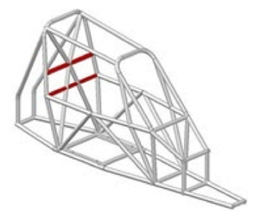

Drawing 279B-14

The height of this reinforcement must be such that the shoulder straps, towards the rear, are installed in compliance with Drawings 253-61-c and 253-61-d.

The straps may be attached by looping or by screws, but in the latter case an insert must be welded for each mounting point (see Drawing 253-67 for the dimensions).

These inserts must be positioned in the reinforcement tube and the straps must be attached to them using bolts of M12 8.8 or 7/16 UNF specification.

Each anchorage point must be able to withstand a load of 15 kN.

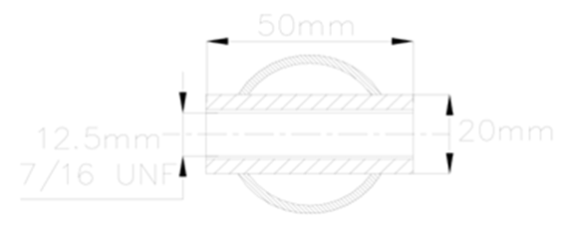

Drawing 253-67

**14.4 Mudguards**

It is obligatory to fix mudguards on each wheel.

They must be made of a flexible plastic material at least 4 mm thick. They must be firmly mounted on minimum 2 mounting brackets.

The mudguards must project over the wheels and provide at all times an efficient covering of at least the entire width of the tyre and must be situated behind the driven wheels no more than 5 cm above the ground.

On the front wheels, the mudguard must cover the wheel at least up to a vertical (Z) plane passing through the front wheel axis.

On the driven wheels, the wheel must not be visible from above.

Mudguards must have no perforations or sharp angles.

Should it be necessary to reinforce the mudguards, this may be done with an aluminium alloy tubing with a maximum diameter of 15 mm.

Under no circumstances may the mudguard reinforcement be used as a pretext for the construction of crash bars or bumpers.

**14.5 Towing device**

One front and one rear towing device are compulsory.

They must:

• Be clearly visible and marked in yellow, red or orange;

• Allow the passage of a cylinder with a diameter of 60 mm;

• Be a belt type, made from soft material;

• Allow the car to be towed on a dry surface (concrete or asphalt), by applying traction on a plane parallel to the ground, with an angle of plus or minus 15 degrees to the longitudinal centreline of the car.

This check must be carried out with the wheels blocked by means of the main braking system.

The car must be fitted with tyres of a type identical to that used during the competition.

It may take place during preliminary scrutineering.

**14.6 Drivers’ equipment**

According to Chapter 3 of Appendix L to the Code.

**Estonian National (valid until 31.12.2026)**

Minimum required safety equipment as follows. Outdated or damaged safety equipment may be detained by the Chief of Scrutineering until the end of the competition.

- Fireproof overalls

- Boots and gloves

- Balaclava

- Head restraint system (HANS)

- Helmet and protective glasses

**Fireproof overalls**

The overalls must comply with at least FIA standard 8856-2000, be valid and in good condition, and be intact. The FIA ​​standard certificate must be sewn onto the collar of the overall. The overalls must consist of only one piece.

Fire-resistant underwear, socks, boots, gloves, balaclava and HANS must have a valid FIA homologation.

In the case of a wet track, it is permitted to use a rain overall used in karting over the fireproof overall. Its use is permitted by the Clerk of the Course, taking into account the weather and track conditions.

**Helmet**

The helmet must have HANS/HYBRID attachment points provided by the manufacturer. A certificate from the manufacturer is required to validate this. The helmet must be used with a HANS/HYBRID device and its weight is free. Tear-off covers may be used on the helmet visor.

**EXAMPLE OF DRAWING WITH ALL MANDATORY MEMBERS (BASE STRUCTURE 1)**

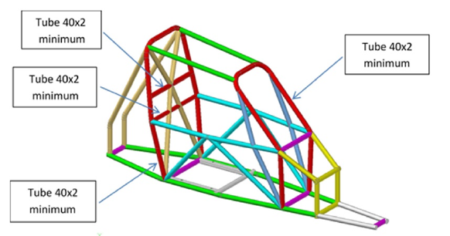

All other coloured tubes must be 40 x 1.5 mm minimum

**EXAMPLE OF DRAWING WITH ALL MANDATORY MEMBERS (BASE STRUCTURE 2)**

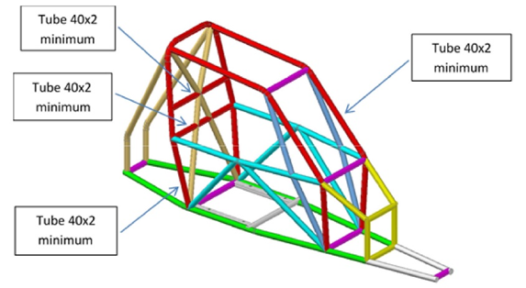

All other coloured tubes must be 40x1.5 mm minimum

**APPENDIX 1**

**Estonian National (valid until 31.12.2026)**

|  |  |  |
| --- | --- | --- |
| **Make** | **Model** | **Model year of the engine** |
| Suzuki | GSXR600 | 2011-2017 |
| Suzuki | GSXR750 | 2005-... |
| Yamaha | MT09 850 | 2016-2020 |
| Yamaha | R6 | 2012-2020 |
| *Yamaha | MT09 890 | 1. -... |

A car using this engine model for racing must fully comply with the FIA ​​autocross technical regulations.

**APPENDIX 2**

**HOMOLOGATED CROSS CARS ENGINES REGISTERED BY THE FIA**

|  |  |  |  |
| --- | --- | --- | --- |
| **FIA**  **REGISTRATION N°** | **MAKE OF THE ENGINE** | **MODEL OF THE ENGINE** | **MODEL YEAR OF THE ENGINE** |
| 2020-01-XCAR-GSXR | SUZUKI | GSXR 600 | 2011-2017 |
| 2020-02-XCAR-MT09 | YAMAHA | MT09 | 2016-2020 |
| 2020-03-XCAR-R6 | YAMAHA | R6 | 2012-2020 |
| 2023-04-XCAR-MT09 | YAMAHA | MT09 889cc | 2021-2023 |

**APPENDIX 3**

Additional requirements for competing in the Estonian Rallycross Championship in 2025

**1. REHVID**

Front: Gold Speed SD 165/70 – 10 (C-9211) – yellow compound

Rear: Gold Speed SD 225/40 – 10 (C-9211) – yellow compound

Front: 90190 Gold Speed C-9203 CR 225-40-10 YELLOW 32N E4

Rear: 90185 Gold Speed C-9205 CR 165-70-10 YELLOW 27N E4

**2. ENGINE SEALING**

For sealing the engine there must be holes on the bolts of the engine block, cylinder head, and chain tensioner.

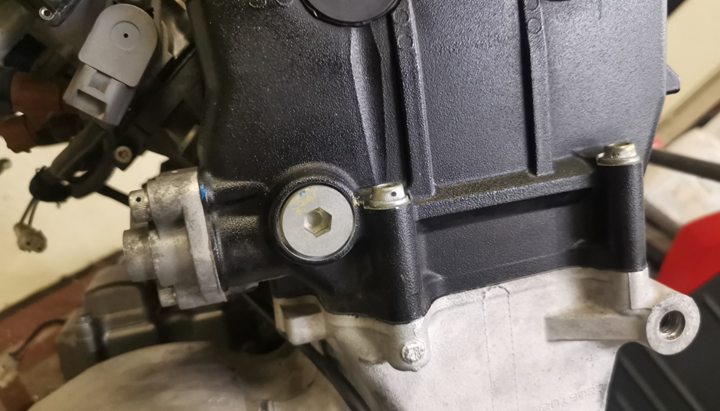

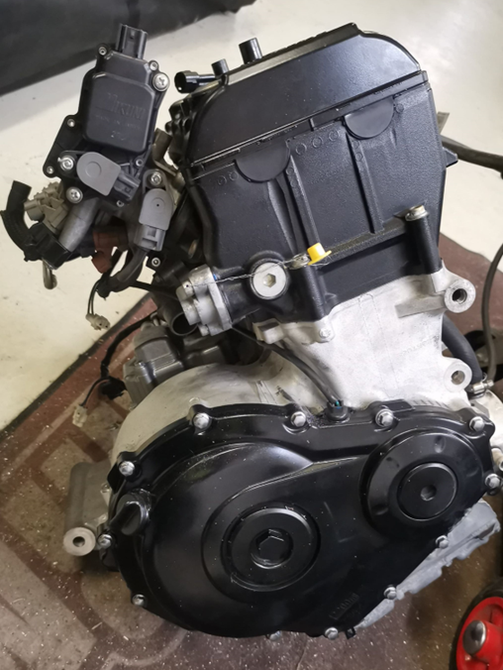

The seal may only be removed during the competition season in the presence of the EASU designated technical delegate or with written permission. When removing the seal, the EASU technical delegate must be allowed to carry out all procedures aimed at verifying the engine's compliance with these technical regulations. If the competitor has not fulfilled the requirements for removing the seal set out in these technical regulations and has removed the seal arbitrarily, the results of all previous rounds of the competitor may be cancelled.

When competing for the first time in the season, the competitor must install the wire necessary for sealing before coming to scrutineering.

The competitor is responsible for the condition of the seals.

**3. ON-BOARD CAMERA**

The cameras to be installed in the car and their mounting method must be presented to scrutineers. The chief scrutineer decides whether the planned mounting method and placement are acceptable.

An on-board camera is a camera that is installed safely and records a moving image from inside the car in such a way that the competition track, steering wheel and pedals are clearly visible from the camera image. The competitor is obliged to use an on-board camera in order to interpret situations arising from the competition situations that may arise during the competition day. To this end, this camera and the location of the camera must be registered at the scrutineering before the start of the free practice. The camera must record the image from the time the competition car enters the pre-start area until it returns to the pit area (in the final, to the parc ferme).

Stewards have the right to require and take into account all cameras when interpreting situations. It is the driver's responsibility to ensure that the camera battery has sufficient capacity and that there is sufficient free space on the memory card.

Stewards have the right to make a decision to the detriment of a competitor who does not have the camera recording of the disputed situation (camera does not record, the battery is dead or the storage space is full, etc.) up to and including disqualification from the competition.